**MCT-338L Embedded Systems II (ES-II)**

**Semester Project (CEP)**

**Submitted To:**

**Mr. Shujat Ali**

**Submitted By: (Group # 2)**

**Zohaib Ayaz (2021-MC-02)**

**Muhammad Anees (2021-MC-03)**

**Muawwiz Ali Yousuf (2021-MC-13)**

**Date:** 9th Jan 2024

________________________________________________________________

**Department of Mechatronics & Control Engineering**

**UNIVERSITY OF ENGINEERING & TECHNOLOGY LAHORE**

Bluetooth Controlled Piano Button

# Project Description

# This project revolves around the integration of a Microcontroller TM4C123GH6PM, Servo motor and a Bluetooth module HC-05 to enable wireless control of an electric board's ON/OFF state. The system employs a 180-degree servo motor programmed through the microcontroller to perform precise rotations, effectively pressing the button on the electric board. Users can effortlessly manipulate the board's status using a smartphone, which communicates with the HC-05 module via UART signals. The Microcontroller TM4C123GH6PM serves as the project's central processing unit, executing a custom-designed algorithm to interpret Bluetooth commands and control the servo motor accordingly. This results in a user-friendly and efficient interface, providing a seamless and convenient experience for home automation enthusiasts. The project's modular design encourages expandability, allowing for future enhancements and integrations to further tailor the smart electric board control system to individual preferences and needs.

# Description of Components:

A wide variety of components are used in this project. The description of these components is given below:

* **Servo Motor (SG-90):**

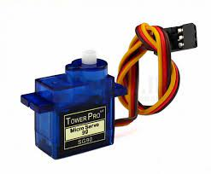A servomotor is a closed-loop servomechanism that uses position feedback to control its motion and final position. The input to its control is a signal (either analog or digital) representing the position commanded for the output shaft.

The motor is paired with some type of position encoder to provide position and speed feedback. In the simplest case, only the position is measured. The measured position of the output is compared to the command position, the external input to the controller. If the output position differs from that required, an error signal is generated which then causes the motor to rotate in either direction, as needed to bring the output shaft to the appropriate position. As the positions approach, the error signal reduces to zero, and the motor stops.

* 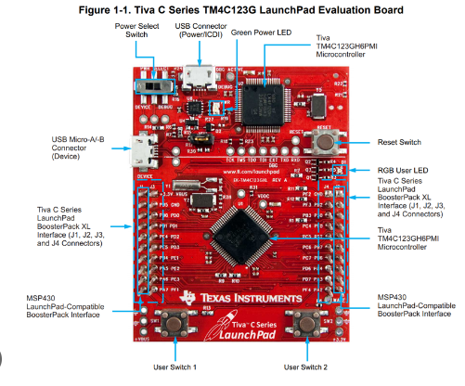**TM4C123GH6PM (Micro Controller):**

The microcontroller used in this project is the TIVA C series TM4C123GH6PM. The TM4C123GH6PM microcontroller is targeted for industrial applications, including remote monitoring, electronic point-of-sale machines, test and measurement equipment, network appliances and switches, factory automation, HVAC and building control, gaming equipment, motion control, and transportation. It is one of the most suitable microcontrollers for this project.

* 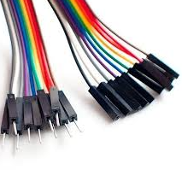**Jumper Wires:**

A jumper wire is an electric wire that connects remote electric circuits used for printed circuit boards. By attaching a jumper wire to the circuit, it can be short-circuited and short-cut (jump) to the electric circuit. Jumper wires are typically used with breadboards and other prototyping tools to make it easy to change a circuit as needed.

* **Power Supply:**

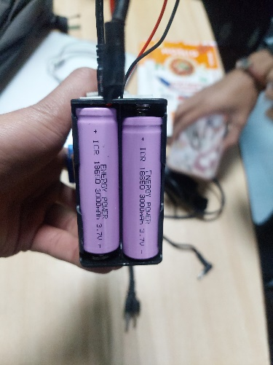A power supply is an electrical device that offers electric power to an electrical load such as a laptop computer, server, or other electronic devices. The main function of a power supply is to convert electric current from a source to the correct voltage, current to power the load. In this project, power is supplied to the components through a 4V power supply.

* **Bluetooth module:**

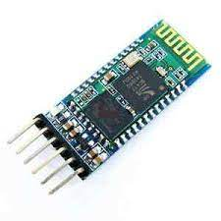The HC-05 is a class 2 Bluetooth module designed for transparent wireless serial communication. It is pre-configured as a slave Bluetooth device. Once it is paired to a master Bluetooth device such as PC, smart phones and tablet, its operation becomes transparent to the user. All data received through the serial input is immediately transmitted over the air. When the module receives wireless data, it is sent out through the serial interface exactly at it is received. No user code specific to the Bluetooth module is needed at all in the user microcontroller program.

* **Electric board:**

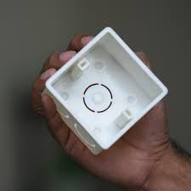An electrical distribution board, also known as a panel board or a breaker panel, is a crucial component in the electrical system of a building. It's responsible for distributing electrical power from the main power supply to the various circuits and appliances throughout the building.

* **Springs:**

A spring is a device made of a rigid material that can return to its original shape after being compressed or extended. Springs can store energy when compressed.

Pinout Connections:

Here are the pinouts of components.

**1.Bluetooth Module:**

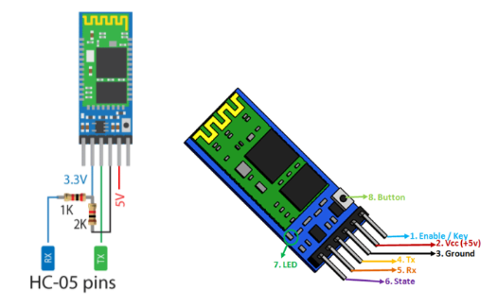

PE5 of TM4C123GH6PM

PE4 of TM4C123GH6PM

**2.Servo Motor:**

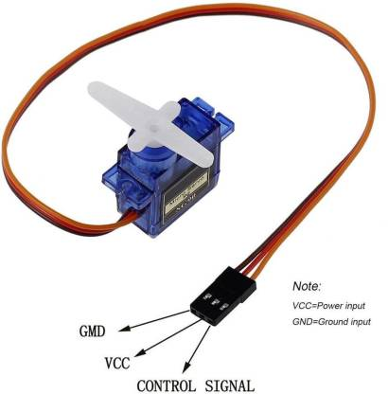

PWM Signal(PB6)

+VCC(VBUS of Tiva)

5V

GND of Tiva

Complete Circuit:

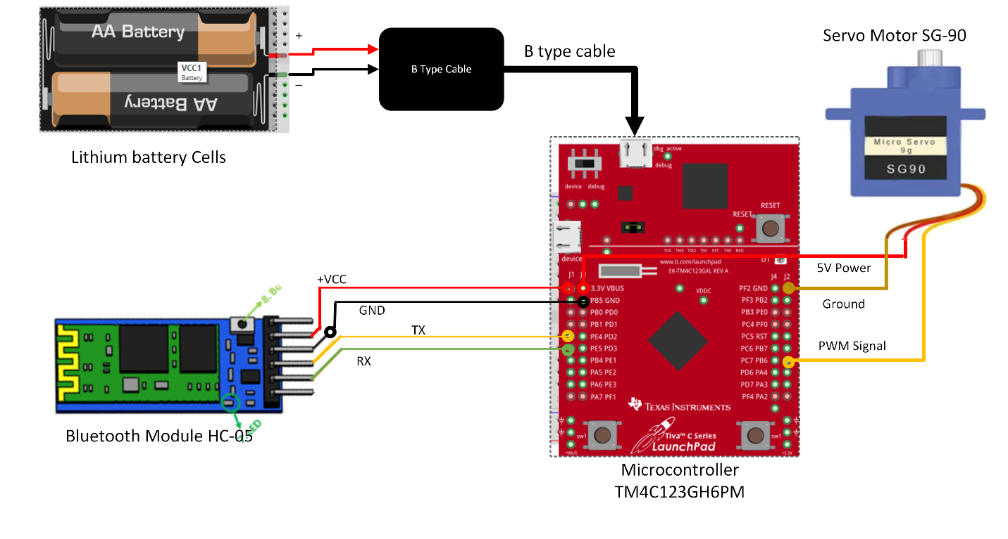

Board Interfacing:

Here is the front and back of the board.

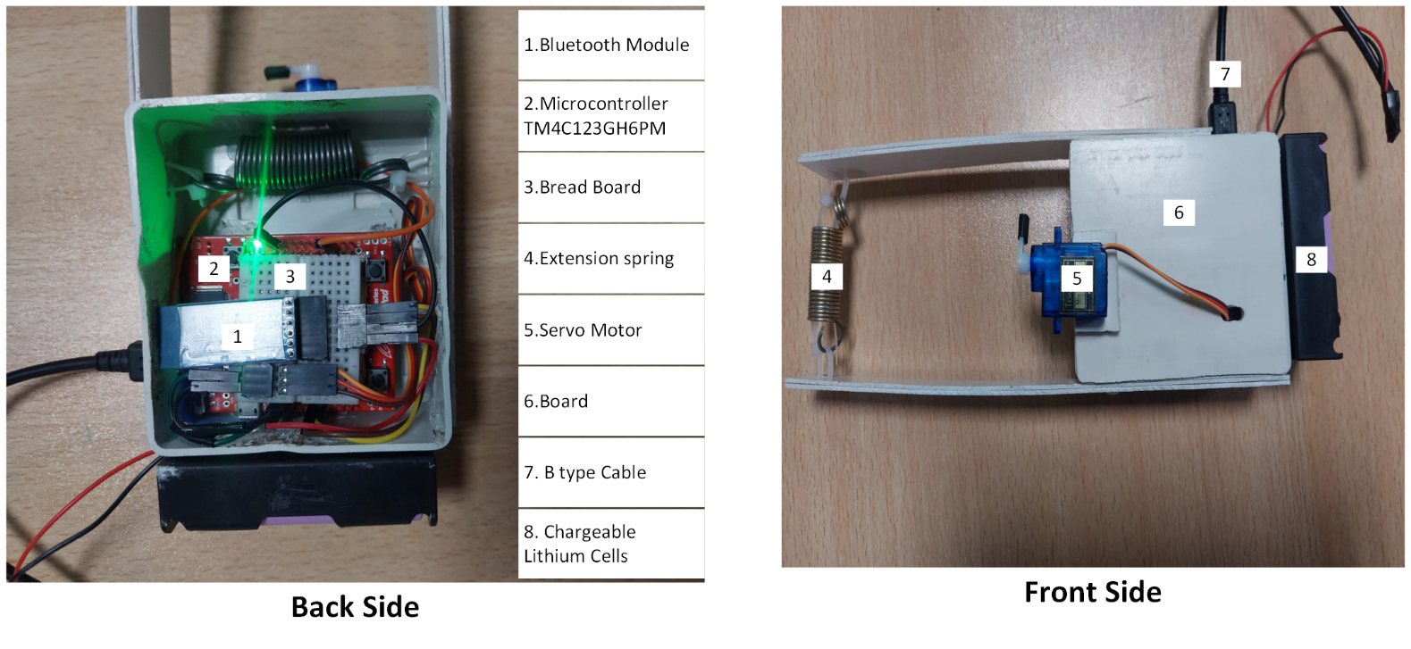

Installed Project:

Here is the complete installation of our project on test board.

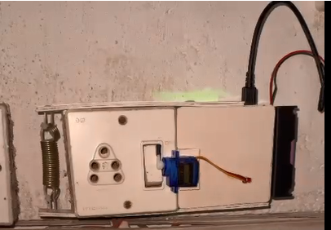

Working Animation:



Bill of Materials:

|  |  |  |  |  |
| --- | --- | --- | --- | --- |
| **Item** | **Quality** | **Price/Unit (Rs)** | **Total (Rs)** | **Vendor** |
| HC-05 Bluetooth Module | 1 | 750 | 750 | <https://digilog.pk/products/05-bluetooth-module-pakistan> |
| Micro Type B Cable | 1 | 150 | 150 | <https://digilog.pk/products/ca-190cd-original-micro-usb-charging-cable-data-cable> |
| Box | 1 | 50 | 50 | <https://watertank.pk/product/wall-box/> |
| Charging Module | 1 | 60 | 60 |  |
| Lithium Ion Cells | 2 | 180 | 360 | <https://digilog.pk/products/used-18650-lithium-cell-pakistan> |
| Cells Case Holding | 1 | 60 | 60 | <https://digilog.pk/products/3x-18650-battery-cell-case-holder-in-pakistan> |
| Servo Motor | 1 | 310 | 310 | <https://epro.pk/product/tower-pro-sg90-9g-micro-servo-motor-with-accessories-blue/> |
| PVC | 1 | 50 | 50 | <https://jbms.pk/pvc-pipe-price-in-pakistan/> |
| Spring | 2 | 50 | 100 | <https://www.starshop.pk/product/prime-line-sp-9623-spring-extension-13-16-inch-by-3-1-8-inch-trampoline--in-pakistan/> |
|  |  | **Total Price = 1890** | |  |
|  |  |  | |  |

Description of Bluetooth App:

This app is developed through MIT App inventor.

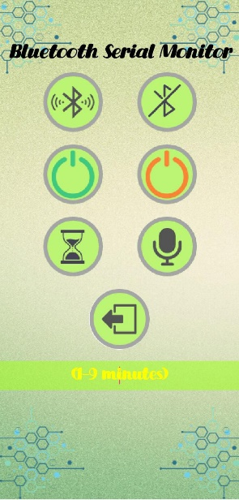

* **Connect Button:**

Connect button is used to scan for available devices that are paired. In fact, it is a list picker to pick a device from available list.

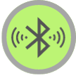

* **Disconnect Button:**

This button is used to disconnect a device from Bluetooth connection.



* **Turn ON Electric Button ON:**

This button is used to turn on button on electric board.



* **Turn OFF Electric Button ON:**

This button turns off the button of electric board.



* **Voice Command:**

This button uses voice commands “button on” and “button off” to turn ON/OFF button of the

electric board.



* **Set Timer:**

This button turns ON electric button and sets a timer for turning OFF electric button in such a way that it takes input through text box and button turns OFF automatically after the time set by user ends.



* **Exit Button:**

This button is used to exit the application.



* **Voice Command status:**

Below exit button there is a label that shows the status of voice commands. If it is valid command executes otherwise invalid command is set on that label.

* **Connectivity and button status:**

Below this label there is another label which shows connectivity status.

Steps to use App:

1. First you need to pair HC-05 by entering password “1234” or “0000”.

2. Click on App icon to start the application.



3. By clicking connect button you pick HC-05 and when it is connected connectivity status is updated in label which remains sets for 2.5 seconds and automatically clears out.

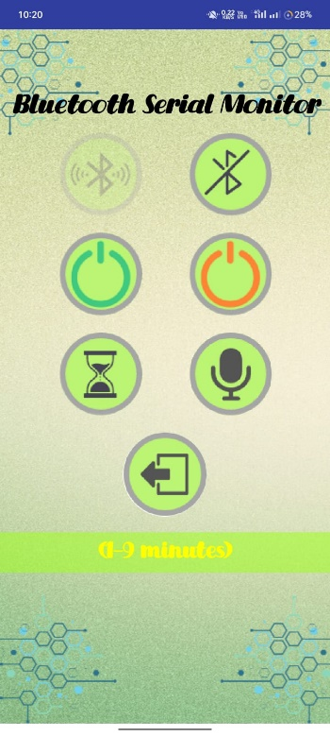 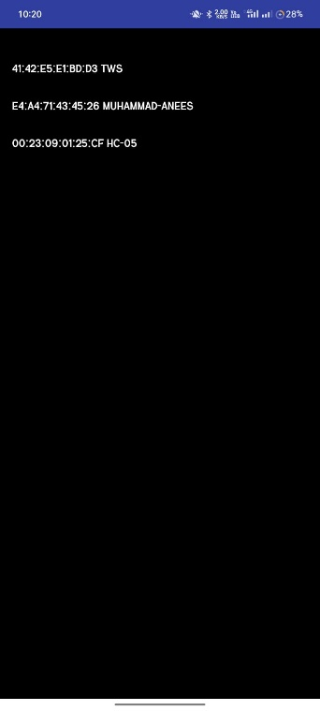

4. Now you can use turn ON/OFF button of app to ON/OFF electric button.

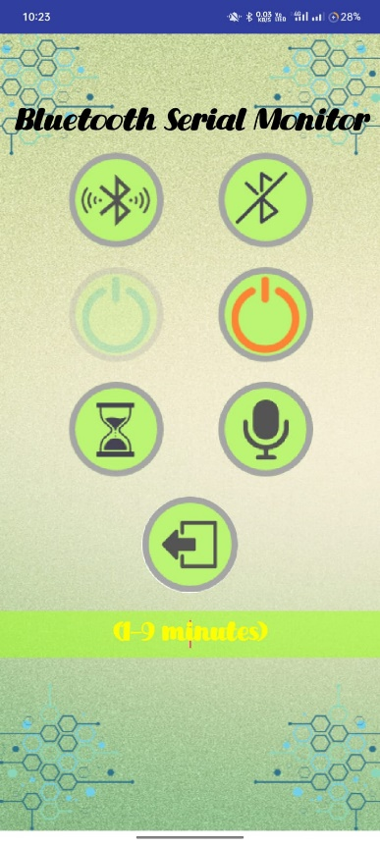 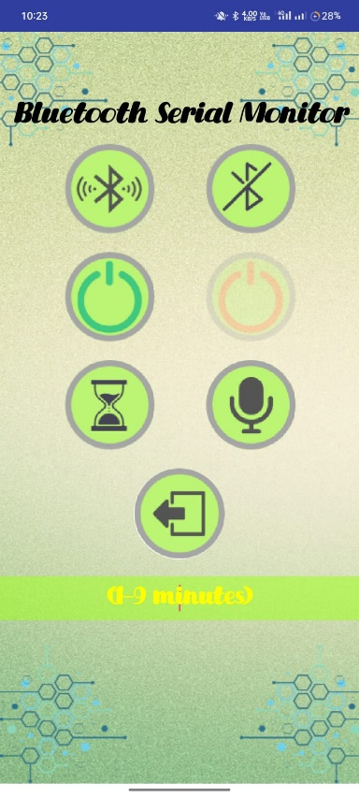

5. You can also use voice commands “button on” and “button off” to turn ON/OFF button of the

electric board.

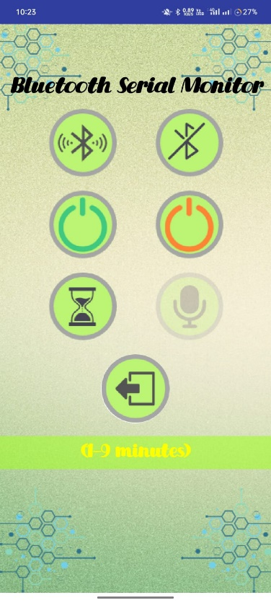 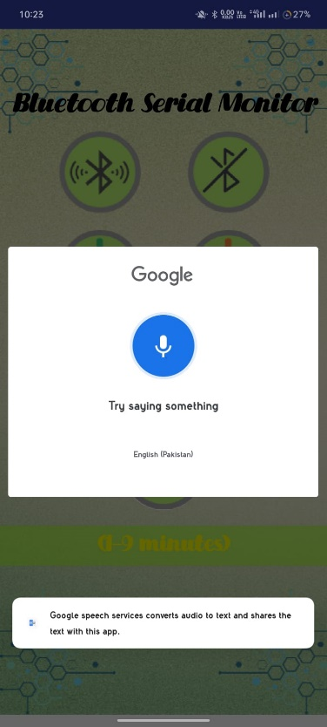

6. You can also set a value (in minutes) in text box and button is automatically turned off after that time.

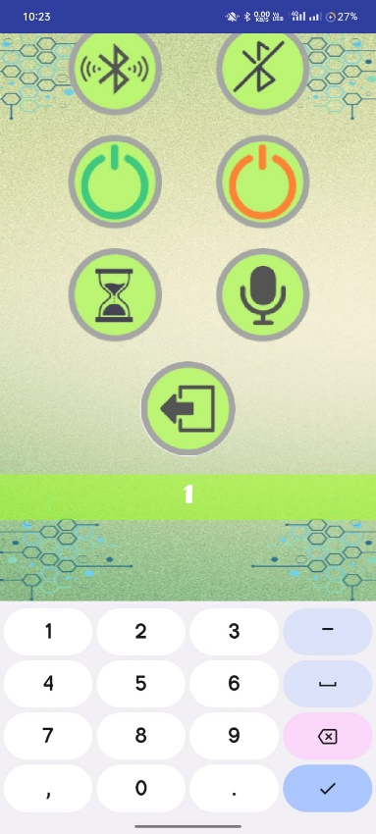 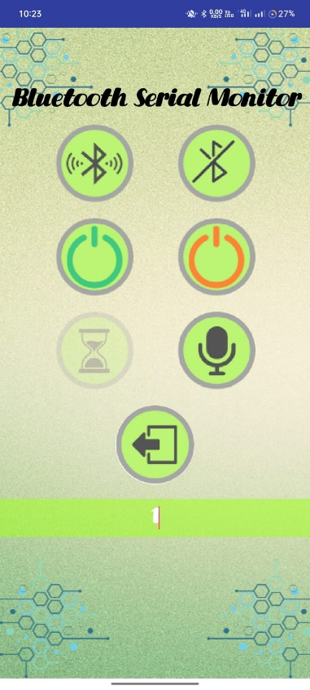

7. You can disconnect using disconnect button.

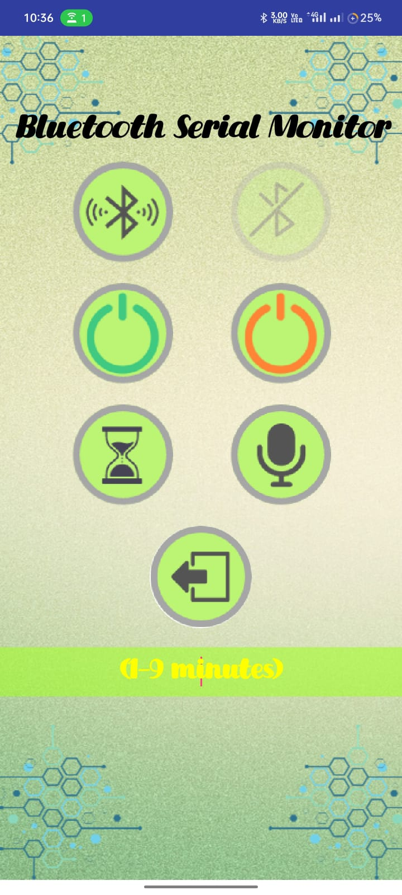

8. You can exit from application by clicking exit button after you confirm it.

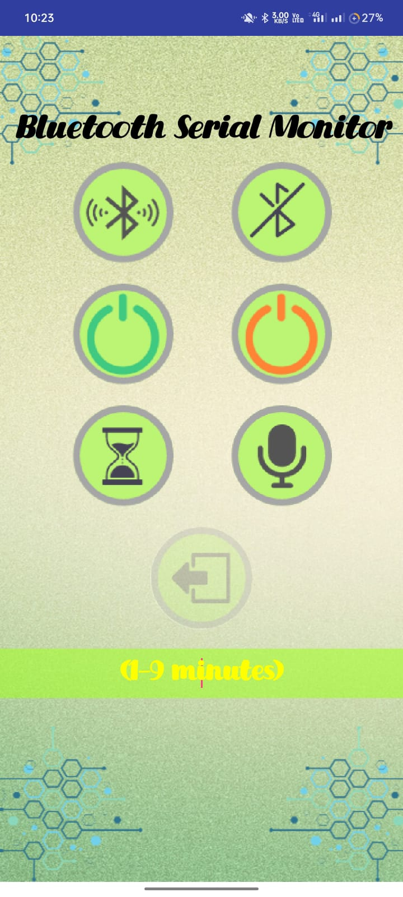 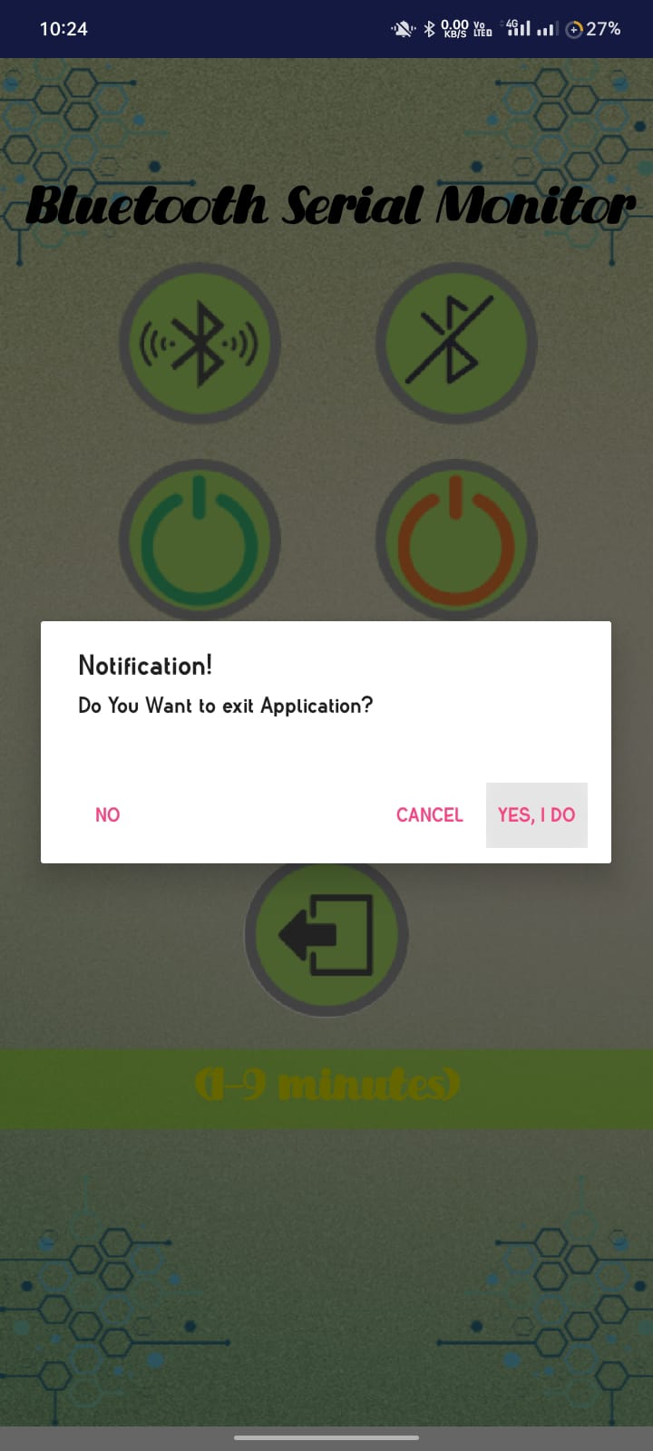

Steps to Develop App:

1. Open MIT App inventor through your web browser and click start new project.
2. There are two setups required for an app i.e blocks(GUI) and designer(Logic Control).
3. First, we will set blocks (how app looks). In media catalog add all of your background images and button images that are prepared from Canva.
4. Click All elements nad click screen 1. Properties catalog for screen will appear. Set screen 1 title to “Bluetooth Seriel Monitorand add image for background of app.
5. Now from palette catalog, in layout pick horizontal arrangement and drop it in viewer window. Add a label from user interface and manage its properties i.e making background invisible and setting font type, fontsize and font color. Write text “Bluetooth Seriel Monitor ” that will display on label. Set the width and hieght of label.
6. Add one list picker annd six buttons from user interface. Add their images from properties bar, adjust their width and height according to your requirement.
7. To adjust the two buttons in a row you need to add horizontal arangement for each pair of button. For adding spacing between a pair of button you can add horizontal arrangement. Rename all the buttons according to their functionality.
8. Below buttons add three horizontal arrangements in columns to add two labels (one for button and connectivity status and other for voice command status). For apacinf add empty horizontal arrangements in columns.
9. Add bluetooth, Notifier, and clock from palette.
10. Now go to blocks window and start building logic.
11. First, we will set listpicker.before picking to set all available devices to be displayed with address and names.   
    
12. Now setup Listpicker.after picking if bluetooth is enabled set all available devices to be displayed with address and names. An address is picked picked by userand if that user is connected label 1 is shows Device connected.

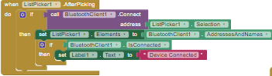

1. Now after 2.5 seconds label1 is cleared automatically this is done using timer of clock. This will also work for voice command label too.

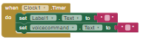

1. After that button 1 that is turn on button if it is pressed bluetooth.Send text will send “B” to UART->DR. and set the label 1 to “Button turned ON”.

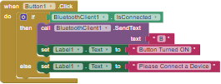

1. After that button 2 that is turn off button if it is pressed bluetooth.Send text will send “A” to UART->DR. and set the label 1 to “Button turned OFF”.

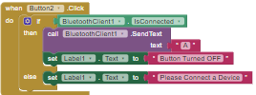

1. After that button 3 is disconnect button we wil call bluetooth.disconnect if is connected and set label1.

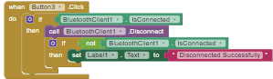

1. Button 4 will take voice throgh voic recognizer and match it with multiple conditions which conditionbecomes true that command is executed.



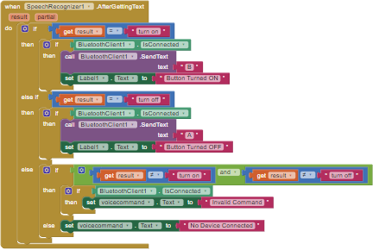

1. Button 5 will send text C that will also takemaessage box. Message box will send number only message to UART->DR.Text C will call third function in C code to turn ON buttun and OFF the electric button automatically after time specified by user in minutes.

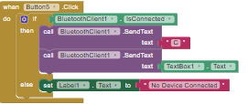

1. Now button 6 is set to call a notifier notifier.ShowChooseDialog in which we will set warning message and its two possible states. If our choice in notifier and button 1 text of notifier matches we will set then to close application.

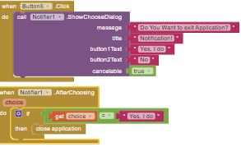

References:

* [https://www.google.com/url?sa=i&url=https%3A%2F%2Fmicrocontrollerslab.com%2Fhc-05-bluetooth-interfacing-tm4c123g-tiva-launchpad-keil-uvision%2F&psig=AOvVaw20A55 Q3libnSxwWH78Zd2&ust=1704957746288000&source=images&cd=vfe&opi=89978449&ved=0CBUQjhxqFwoTCODEl9mk0oMDFQAAAAAdAAAAABAD](https://www.google.com/url?sa=i&url=https%3A%2F%2Fmicrocontrollerslab.com%2Fhc-05-bluetooth-interfacing-tm4c123g-tiva-launchpad-keil-uvision%2F&psig=AOvVaw20A55%20Q3libnSxwWH78Zd2&ust=1704957746288000&source=images&cd=vfe&opi=89978449&ved=0CBUQjhxqFwoTCODEl9mk0oMDFQAAAAAdAAAAABAD)
* <https://ai2.appinventor.mit.edu/#5717938082283520>
* <http://www.ee.ic.ac.uk/pcheung/teaching/DE1_EE/stores/sg90_datasheet.pdf>
* <https://www.ti.com/lit/gpn/TM4C123GH6PM>
* <https://www.electronica60norte.com/mwfls/pdf/newBluetooth.pdf>
* <https://randomnerdtutorials.com/tag/hc-05/>